News Release 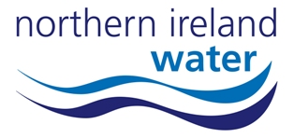
01 October 2009
NI Water Announces New £180k Pumping Station for Draperstown

Northern Ireland Water (NI Water) is delighted to announce a significant investment in Draperstown, which will fund the construction of a new sewage pumping station and associated pumping main. The £180,000 facility will be built at the site of an existing station and will be constructed in line with the latest environmental standards. It will mean NI Water can meet the demands of a growing community and offer an enhanced level of service.

NI Water Project Manager, Dermot Lynch said:
“This project is clear evidence of NI Water’s commitment to investing in and improving the water and sewage infrastructure across Northern Ireland. It demonstrates our promise to deliver an efficient and effective service for NI Water customers.

“The programme of work, which comprises the construction of a new pumping station and the installation of 800m of new pumping main along Tobermore Road, has been designed with our customers needs in mind. We will continue to work with Roads Service and local authorities to ensure minimal disruption to businesses and the public.”

The work is expected to commence early this month and will last for approximately ten weeks.

For further information regarding this project, please contact NI Water’s customer relations team through Waterline on 08457 440088 and quote Draperstown Stage 2.
Ends//…
Notes to Editors:
- Media enquires should be directed to NI Water Press Office on 028 9035 7695 or alternatively via email, press.office@niwater.com.

